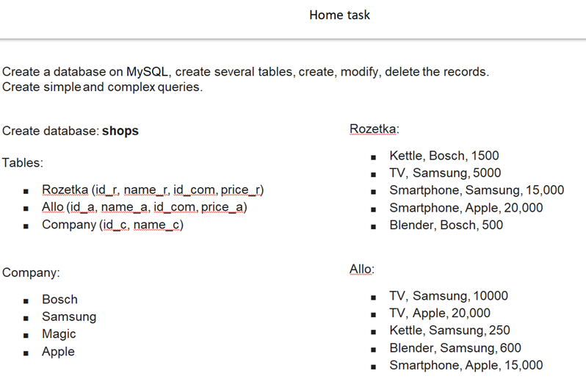

A task:

1. Make a simple selection for each table
2. Sort each table by company
3. Group table by name
4. Select the maximum price value for each table
5. Calculate the total cost of goods in each table
6. Make a selection of all smartphones from all tables (product name, price, company)
7. Make a selection of all Bosch products for all products table
8. Select Samsung products from all tables where price more than 600
9. Select smartphones worth more than 15,000

**Create database Shops using MySQL 8.0 Command Line Client - Unicode**

mysql> show databases;

mysql> create database Shops;

mysql> use Shops;

Database changed

**Create table Company using MySQL 8.0 Command Line Client - Unicode**

mysql> create table company (id_c int auto_increment primary key, name_c varchar(30)not null);

mysql> insert into company (name_c) value ('Bosch');

mysql> insert into company (name_c) value ('Samsung');

mysql> insert into company (name_c) value ('Magic');

mysql> insert into company (name_c) value ('Apple');

mysql> select*from company;

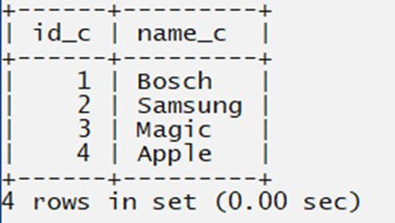

**Create table Rozetka using MySQL Workbench**

create table rozetka (id_r int auto_increment primary key, name_r varchar(30), id_com varchar(30), price_r int);

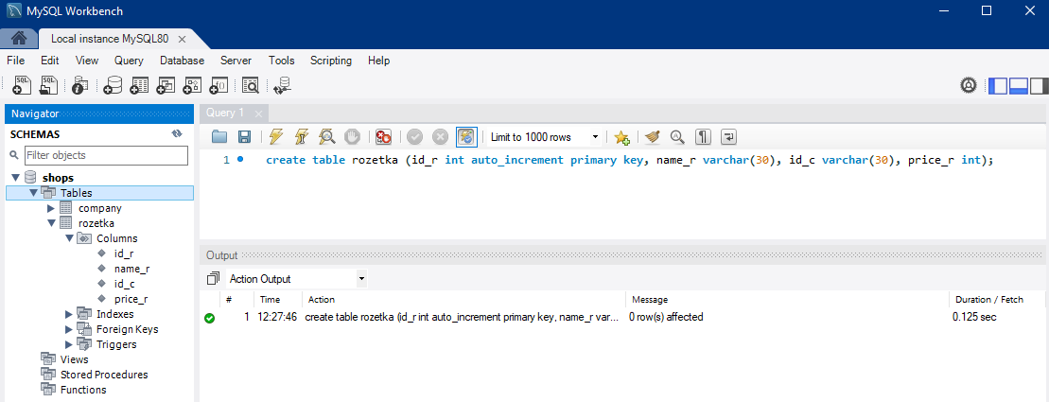

insert into rozetka (name_r,id_com,price_r)

values ('Kettle', 'Bosch', 1500);

insert into rozetka (name_r,id_com,price_r)

values ('TV', ‘Samsung’, 5000);

insert into rozetka (name_r,id_com,price_r)

values (‘Smartphone’, ‘Samsung’, 15000);

insert into rozetka (name_r,id_com,price_r)

values ('Smartphone', ‘Apple’, 20000);

insert into rozetka (name_r,id_com,price_r)

values ('Blender', ‘Bosch’, 500);

**Create table Allo using MySQL Workbench**

create table allo (id_a int auto_increment not null primary key, name_a varchar(30) not null, id_com varchar(30) not null, price_a int not null);

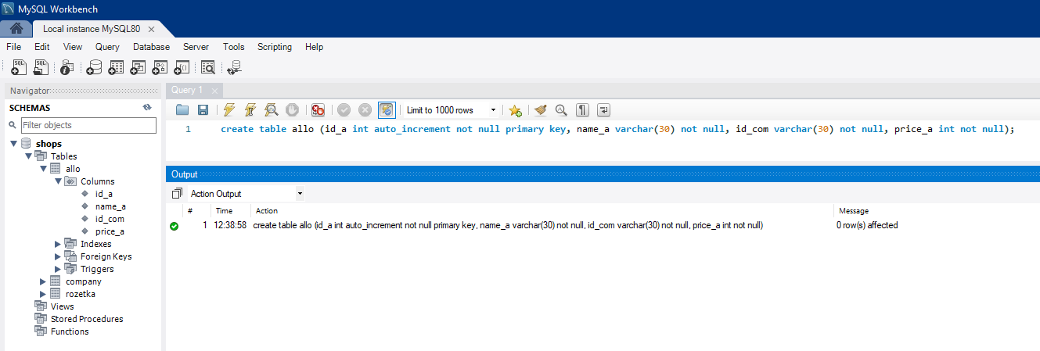

insert into allo (name_a, id_com, price_a)

values ('TV', 'Samsung', 10000);

insert into allo (name_a, id_com, price_a)

values ('TV', ‘Apple’, 20000);

insert into allo (name_a, id_com, price_a)

values ('Kettle', ‘Samsung’, 250);

insert into allo (name_a, id_com, price_a)

values ('Blender', ‘Samsung’, 600);

insert into allo (name_a, id_com, price_a)

values ('Smartphone', ‘Apple’, 15000);

1. **Make a simple selection for each table**

SELECT*FROM company;

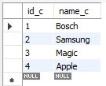

SELECT*FROM rozetka;

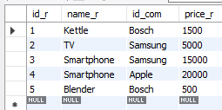

SELECT*FROM allo;

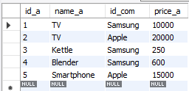

SELECT id_a, name_a FROM allo;



SELECT name_r, price_r FROM rozetka;

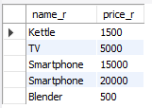

1. **Sort each table by company**

SELECT*FROM allo

ORDER BY id_com DESC;

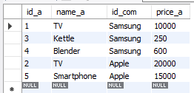

SELECT*FROM company

ORDER BY name_c DESC;

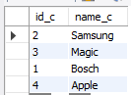

SELECT*FROM rozetka

ORDER BY id_com ASC;

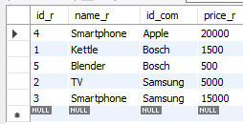

1. **Group table by name**

SELECT count(id_r), name_r, id_com, price_r

FROM rozetka

GROUP BY name_r;

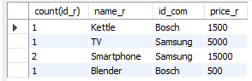

SELECT count(id_a), name_a, id_com, price_a

FROM allo

GROUP BY name_a;

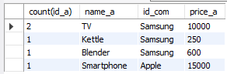

SELECT count(id_c), name_c

FROM company

GROUP BY name_c;

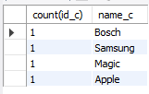

1. **Select the maximum price value for each table**

SELECT max(price_a) AS LargestPrice

FROM allo;



SELECT max(price_r) AS LargestPrice

FROM rozetka;



1. **Calculate the total cost of goods in each table**

SELECT sum(price_a)

FROM allo;



SELECT sum(price_r)

FROM rozetka;



1. **Make a selection of all smartphones from all tables (product name, price, company)**

SELECT name_a, id_com, price_a

FROM allo

WHERE name_a = 'Smartphone';



SELECT name_r, id_com, price_r

FROM rozetka

WHERE name_r = 'Smartphone';



SELECT*FROM allo

WHERE name_a LIKE '%Smartphone%'

UNION ALL

SELECT*FROM rozetka

WHERE name_r LIKE '%Smartphone%';

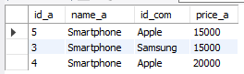

1. **Make a selection of all Bosch products for all products table**

SELECT id_r, name_r, id_com, price_r

FROM rozetka

WHERE id_com = 'Bosch';

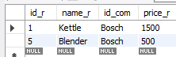

SELECT * FROM rozetka

WHERE id_com LIKE 'Bosch';

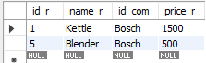

SELECT id_a, name_a, id_com, price_a

FROM allo

WHERE id_com = 'Bosch';



SELECT*FROM allo

WHERE id_com LIKE '%Bosch%'

UNION

SELECT*FROM rozetka

WHERE id_com LIKE '%Bosch%';

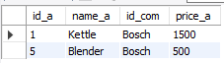

1. **Select Samsung products from all tables where price more than 600**

SELECT*FROM allo

WHERE price_a > 600

AND id_com='Samsung'



SELECT*FROM rozetka

WHERE price_r > 600

AND id_com='Samsung';

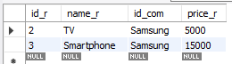

1. **Select smartphones worth more than 15,000**

SELECT*FROM rozetka

WHERE name_r='Smartphone'

AND price_r > 15000;

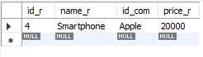

SELECT*FROM allo

WHERE name_a='Smartphone'

AND price_a > 15000;

